MDFO CADRe Part A
Office of Mission Cost Analysis
Cost Analysis Data Requirements (CADRe)
PART A
Mission: Myralis Dust Field Observatory
Design Reference: Preliminary integrated baseline
Key Decision Point: CDR
Project Gate: R3
Draft 1.0 | 22 September 2026
This document describes one entirely synthesized mission, including its organizations, spacecraft and data.

Revision History
Rev. | Description | Prepared by | Date
Draft 1.0 | Initial integrated architecture and cost-analysis baseline | Mission Analysis Office | 22 Sept 2026

Table of Contents
1 Introduction
1.1 Purpose of this document
1.2 Purpose and scope of mission
2 General Descriptive Information
2.1 Mission Overview
2.2 Context
2.3 Strategic Objectives
2.4 Selected Mission Requirements
2.5 High-Level Mission Architecture
3 Space Segment Description
3.1 Spacecraft Bus
3.2 Payload
4 Launch Segment Description
5 Ground Segment and Mission Operations
6 Systems Engineering and Project Management Approach
6.1 TRL Levels and Heritage
6.2 Phasing Logic and Naming Conventions
6.3 Project Milestones
6.4 Safety and Mission Assurance
6.5 Qualification and Acceptance Strategy, Model Philosophy
6.6 Risk Assessment
6.7 Organizational Breakdown Structure
Appendices
A Acronym List

List of Figures
Figure 1 – Myralis mission concept and reference heliocentric geometry
Figure 2 – Spacecraft power architecture and budget
Figure 3 – Attitude control and observation modes
Figure 4 – Three spacecraft launch configuration
Figure 5 – Ground mission network and data flow

List of Tables
Table 1 – Strategic Alignment
Table 2 – Selected Mission Requirements
Table 3 – Preliminary Spacecraft Allocation and Reference Data
Table 4 – Project Milestones

1 Introduction

1.1 Purpose of this document
CADRe Part A provides a standardized mission synopsis for cost estimating. It brings the mission objectives, technical allocations, operating concept, schedule and organizational responsibilities into a single reference baseline. Quantities below are preliminary requirements or estimating assumptions as marked; detailed design and verification will refine them.
Specifically, CADRe Part A:
- summarizes the mission architecture and cost-driving quantities;
- collects technical and programmatic assumptions in one controlled record;
- sets common definitions for spacecraft, launch, ground and operations scope;
- identifies quantities to reconcile with schedule, risk and procurement records; and
- preserves a traceable starting point for independent cost analysis.
This Part A is a concept-level cost input. The corresponding Part B technical parameter register, Part C schedule and risk baseline, and Part D procurement record must carry the same controlled quantities before an estimate is approved.

1.2 Purpose and scope of mission
The Myralis Dust Field Observatory (MDFO) measures the spatial and temporal distribution of micrometre to millimetre particles across an inner heliocentric annulus. Three identical spacecraft, D1–D3, leave one launch vehicle and drift onto separated solar orbits. Each records local impacts and optical dust brightness; time-correlated measurements constrain a three-dimensional dust-density model. The reference science region spans 0.97–1.03 astronomical units (AU), with useful spacecraft separation of 0.04–0.20 AU after deployment.
The mission seeks to determine dust flux by size and direction, identify transient dust enhancements, and produce a calibrated environmental model for vehicle shielding and long-range mission planning. It does not assume imaging of a celestial surface, landing, sampling, or a relay satellite. The sponsor and owner is the Avelune Space Directorate (ASD), with scientific leadership from the Ruvellan Data Institute (RDI).

2 General Descriptive Information

2.1 Mission Overview
MDFO comprises three 210 kg-class flight spacecraft launched together. Differential separation impulses create modestly different heliocentric periods. A daily spacecraft science return of 0.75 GB (2.25 GB for the constellation) supports event counts, spectra, photometry and housekeeping. A common flight design reduces recurring manufacture and qualification effort. A five-year nominal science phase begins after a six-month cruise and commissioning period.
The measurement strategy combines local impact counting with line-of-sight optical photometry. Correlation of measurements at multiple orbital longitudes constrains regional density changes; individual dust grains are not tracked between spacecraft. A simultaneous viewing window of at least 12 hours per week is planned when geometry permits. Ground inversion is responsible for separating dust brightness from background stars and stray light.
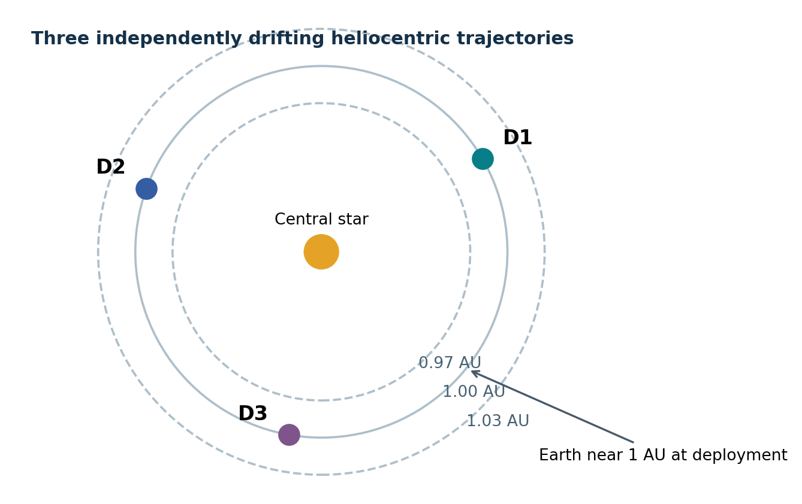
Figure 1 – Reference heliocentric geometry. Radial separation is exaggerated; rings show the analysis region, not fixed operational orbits; D1–D3 drift independently after separation.

2.2 Context
Dust impact flux varies with particle size, heliocentric distance and orbital direction. Single-point counts cannot distinguish local enhancements from a spatial gradient without additional assumptions. Three separated measurement stations improve the conditioning of the inversion and provide spatially distributed evidence over a five-year interval. The architecture trades larger flight-unit count and deep-space communication capacity against a single-point observatory.
No existing supplier or instrument configuration is presumed. The concept baseline includes one common bus, one common payload suite per spacecraft, a three-unit launch dispenser, three ground antenna sites, an operations center, an archive and five years of science processing.

2.3 Strategic Objectives
Table 1 – Strategic Alignment
Objective | Quantified outcome | Measurement basis
Characterize dust environment | Flux from 10⁻¹³ to 10⁻⁶ kg particles in ≥8 logarithmic mass bins | Impact charge and momentum proxies
Resolve heliocentric gradients | Map 0.97–1.03 AU with ≤0.01 AU radial grid spacing where coverage supports it | Distributed local counts + photometry
Detect temporal change | Identify ≥30% flux changes sustained for ≥48 h at 95% confidence in a defined count-rate regime | Time-binned event series
Deliver reference products | Monthly Level 2 flux maps within 30 days of month end | Calibrated archive and inversion pipeline

2.4 Selected Mission Requirements
The values below define the preliminary estimating baseline. Requirements apply to each spacecraft unless stated otherwise. Sensitivity and confidence claims are conditional on a minimum of 100 valid impacts in the relevant comparison bin; low-count regimes will carry Poisson confidence intervals rather than a blanket detection guarantee.
Table 2 – Selected Mission Requirements
Area | Key requirement
Flight architecture | Three near-identical independent spacecraft; one launch and sequential separation.
Science region | Heliocentric radius 0.97–1.03 AU; operational solar elongation 40°–140° for photometry.
Nominal life | Five years of science after six-month cruise/commissioning; propellant and reliability sized to six years after launch.
Spacecraft mass | ≤210 kg launch mass per flight unit; three-unit launch stack ≤790 kg including 160 kg dispenser/adaptor allowance.
Impact measurement | 10⁻¹³–10⁻⁶ kg particles; ≥0.10 m² effective sensitive area; dead time ≤2 ms per accepted event.
Flux dynamic range | 10⁻⁶ to 10² impacts m⁻² s⁻¹ with selectable event threshold and saturation flagging.
Optical photometry | Three bands centered at 0.48, 0.72 and 1.05 µm; ≥20° field; ≤1% relative repeatability for calibrated brightness >100 nW m⁻² sr⁻¹.
Pointing and knowledge | ≤0.20° absolute pointing error and ≤0.05° knowledge for photometric scans (95th percentile).
Orbit knowledge | ≤20 km position uncertainty (3σ) for science geolocation after ground solution.
Autonomy | ≥96 h safe-mode operation without a ground contact; ≥7 days autonomous stored-data retention.
Storage | ≥64 GB usable nonvolatile storage per spacecraft, with error correction.
Data volume | 0.75 GB/day per spacecraft average; 1.5 GB/day per spacecraft 95th-percentile planning case.
Communications | X-band ≥2 Mb/s user data rate at 1.5 AU range to 12 m-class antenna at ≥3 dB link margin; S-band command ≥2 kb/s.
Science latency | Priority event packet delivered ≤24 h after ground receipt; routine L1 ≤7 days; L2 ≤30 days.
Power | 780 W end-of-life generation at 1 AU; nominal science demand ≤410 W; maximum simultaneous peak ≤625 W.
Thermal | Bus avionics 0–40 °C operating; impact electronics −10–45 °C; detector surfaces calibrated over −20–50 °C.
Reliability | ≥0.80 probability of ≥2 functional spacecraft at end of year five, to be validated by reliability analysis.
Ground capacity | Three 12 m-class antenna sites; 15 GB/day raw ingest capability; 120 TB managed archive.
Disposal | Commanded passivation at end of operations; no Earth re-entry or planetary impact in the reference case.

2.5 High-Level Mission Architecture
- Government Segment: ASD owns mission requirements, systems engineering, procurement, project controls and mission acceptance.
- Space Segment: D1, D2 and D3 share a bus and each carries an impact detector, a three-band photometer and a plasma/context package.
- Launch Segment: one launch, a three-port dispenser, sequential deployment and injection into a heliocentric transfer.
- Ground Segment: three geographically separated antennas, a mission-control center, flight dynamics, processing and archive.
- Operations Segment: one staffed daily operations shift with 24-hour automated monitoring and on-call anomaly response.
- Science Segment: RDI maintains the calibration/inversion pipeline and releases controlled Level 1 and Level 2 products.

3 Space Segment Description
The space segment consists of three flight units with common hardware and software baselines. Each unit is independently power positive and commandable after separation. Table 3 distinguishes mass allocations from performance targets; the flight design must close against both.

3.1 Spacecraft Bus
Table 3 – Preliminary Spacecraft Allocation and Reference Data
Parameter | Per spacecraft allocation / target
Dry bus including structure, avionics, ADCS, propulsion hardware | 104 kg
Payload suite including electronics and accommodation | 38 kg
Propellant and pressurant | 24 kg
Harness, thermal and mechanical provisions | 14 kg
Allocated mass subtotal | 180 kg
Unallocated system mass reserve | 30 kg (16.7% of allocated subtotal)
Maximum launch mass | 210 kg
Usable mission-data storage | 64 GB minimum
Δv capacity | ≥180 m/s, including 25% propellant/dispersion reserve
EOL power generation at 1 AU | 780 W
Nominal / peak loads | 410 W / 625 W
Maximum commanded autonomy | 96 h safe mode

Structural Subsystem
A central aluminum alloy shear structure transfers 210 kg maximum flight mass into a standard separation ring. Two hinged array wings, a fixed impact plate and an offset optical baffle fit inside a 1.55 m × 1.35 m × 1.65 m allocated stowed envelope. The preliminary first-mode targets are ≥25 Hz lateral and ≥40 Hz axial, subject to launch-provider coupled-loads analysis. A spacecraft-level finite-element model controls local instrument interface accelerations and alignment drift.
Mass properties shall be measured for each unit before shipment. The bus is sized for 6 g quasi-static axial loading and 2 g lateral loading at concept level; final qualification levels and factors derive from the selected launch service. A 210 kg unit at 6 g produces approximately 12.4 kN axial inertial load before factors of safety.

Electrical Power Subsystem
Each spacecraft carries two deployable arrays with a combined 3.0 m² active area. The estimating case assumes 30% end-of-life cell efficiency and 1,361 W/m² irradiance at 1 AU, giving 1,225 W ideal normal-incidence power. A combined incidence, wiring, thermal and conversion derating of 0.637 yields 780 W at 1 AU. At 1.03 AU, available power falls to approximately 735 W by inverse-square scaling, before battery support. The science timeline limits sustained deep-space demand to 430 W and prohibits the 625 W peak mode without load shedding.
A 28 V regulated bus and 1.6 kWh usable lithium-ion battery cover deployment, brief array off-pointing and transmitter peaks. With 150 W safe-mode load, the battery provides approximately 10.7 h before reserve constraints. The 96 h autonomy requirement assumes solar array generation, not battery-only survival. A 20% minimum nominal power margin applies at the 1.03 AU operating case: 735 / 430 − 1 = 71%.
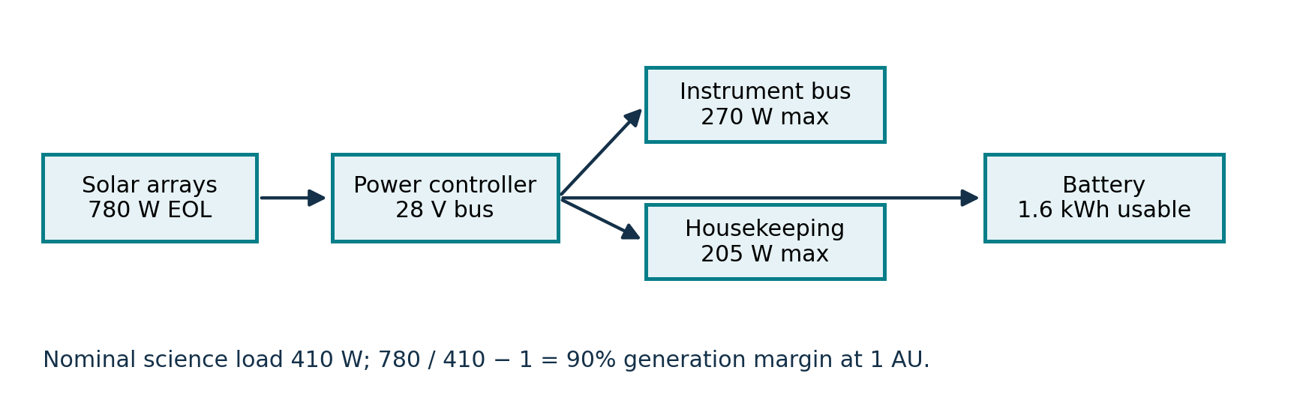
Figure 2 – Per-spacecraft power distribution at 1 AU. Values are end-of-life planning allocations; mode-specific loads and distance scaling govern operation.

Command and Data Handling
Dual redundant flight processors execute command sequences, onboard event filtering, safe-mode logic and time-tagged instrument operations. A radiation-tolerant 64 GB usable storage partition includes error detection and correction; at the 1.5 GB/day planning peak it stores more than 42 days of science data, subject to a 15% housekeeping and file-system allowance reducing practical retention to approximately 36 days. The seven-day retention requirement therefore has substantial headroom.
Impact records include time to ≤100 µs UTC-equivalent accuracy after time correlation, detector charge, event classification, spacecraft state and quality flags. The payload data interface sustains ≥5 MB/s during burst acquisition. Daily average 0.75 GB is 69 kb/s over 24 h; link sizing is driven by contact duration, range and outage, not the average rate alone.
Fault protection detects processor watchdog expiry, battery undervoltage, uncommanded attitude rates, thermal excursions and loss of communications. It isolates a failed device, enters a Sun-safe attitude and retains at least 96 h of time-tagged recovery instructions. All three spacecraft carry separately uploaded command and software baselines.

Thermal Subsystem
Passive coatings, multilayer insulation, radiator panels, straps and thermostatically controlled heaters maintain the bus limits. Solar input at 0.97 AU is 1.063 times the 1 AU value; the radiator and baffle design is sized for a 0.97 AU hot case with a 625 W peak load of no more than 20 minutes. A 1.03 AU cold case assumes safe mode, low instrument dissipation and reduced incident flux. Preliminary radiator allocation is 0.65 m² per spacecraft; detailed orbital thermal analysis shall determine the final area.
Temperature sensors are distributed across the photometer bench, impact front end, battery, propulsion lines and array hinges. Ground calibration shall measure photometric responsivity across −20 to 50 °C detector temperature and shall support temperature correction in Level 1 products.

Attitude Determination and Control Subsystem
Two star trackers, six coarse Sun sensors, one inertial measurement unit and four reaction wheels support three-axis control. Eight cold-gas attitude thrusters provide wheel desaturation and safe recovery. The science attitude keeps the optical axis within 40°–140° solar elongation and rotates the impact detector toward the expected dust ram direction when thermal limits allow. Photometric scans require ≤0.20° 95th-percentile absolute pointing error and ≤0.05° knowledge. Wheel jitter allocation is ≤30 arcsec rms across a 10 s exposure.
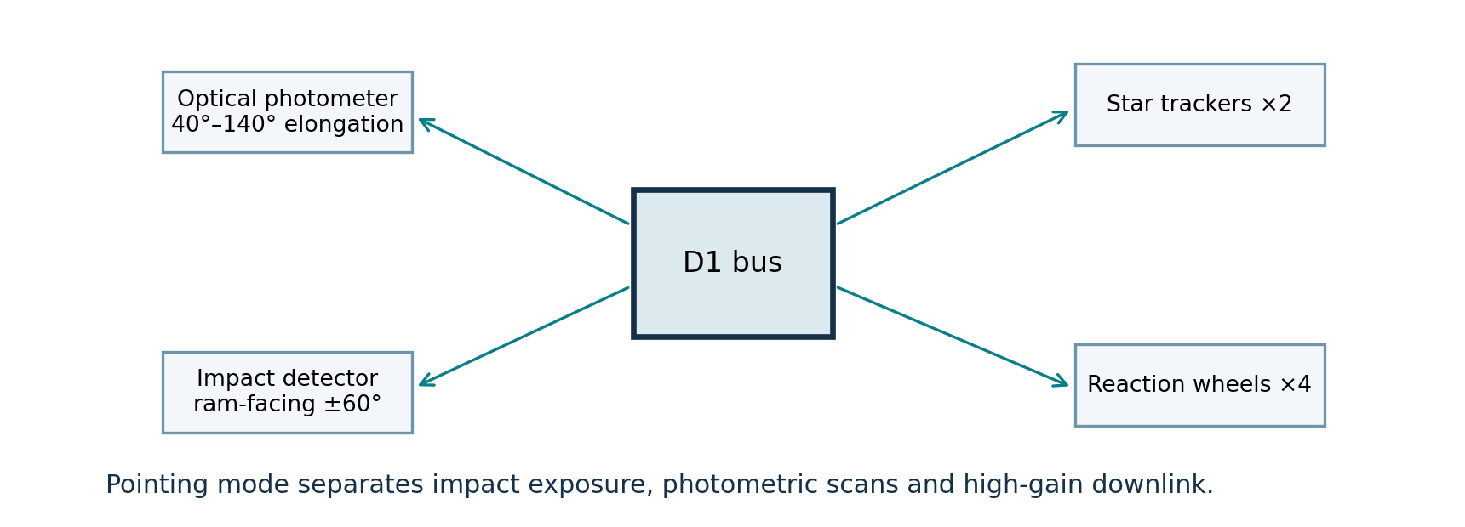
Figure 3 – Instrument fields and attitude modes. The arrows indicate functional interfaces; scan, impact and downlink modes are scheduled separately.

Propulsion Subsystem
A monopropellant system with four 5 N thrusters provides separation corrections and orbit trimming. An effective specific impulse of 225 s and 24 kg propellant at 210 kg initial mass yield ideal Δv ≈267 m/s from the rocket equation; after 20% unusable/contingency allowance, the usable planning capability is approximately 214 m/s. The requirement is 180 m/s, leaving 34 m/s design headroom. This calculation is a reference sizing check, not a final performance guarantee.
Δv use | Allocation
Post-separation phasing | 70 m/s
Cruise trajectory corrections | 35 m/s
Five-year orbit maintenance and geometry control | 25 m/s
Momentum management / contingencies | 14 m/s
Navigation and performance reserve | 36 m/s
Total requirement | 180 m/s
Orbit dispersion and fuel use will be propagated across the three units; none requires a target-body insertion burn. A collision-avoidance separation analysis is required through the first 72 h after release. Commanded passivation vents residual propellant and discharges stored energy at end of operations.

Telemetry, Tracking and Command
A low-gain S-band link supports contingency commanding at ≥2 kb/s. A two-axis pointed X-band high-gain antenna supports ≥2 Mb/s user data at 1.5 AU with ≥3 dB link margin to a 12 m-class receiving station, assuming a 20 W RF transmitter; the final link budget must establish antenna gain, weather allowance, coding loss and ground-equipment noise temperature. The X-band downlink is scheduled for up to 60 minutes per spacecraft per day on average.
At 2 Mb/s, one hour provides 0.9 GB before protocol overhead; a 0.75 GB daily return requires ≥83.3% end-to-end payload efficiency for that contact. The 95th-percentile case of 1.5 GB requires about 100 minutes at the same efficiency, or a higher effective rate. Antenna time, range variation and weather outages are direct operations-cost drivers.

3.2 Payload
Each spacecraft carries three coordinated measurement packages: an impact ionization detector (IID), a three-band dust-scattered-light photometer (DSP) and a compact plasma/context sensor (PCS). A common electronics unit applies timestamps, onboard screening and data compression. The total payload allocation is 38 kg and 270 W peak; instrument simultaneous use is constrained by the spacecraft power case.

Impact Ionization Detector
An exposed 0.12 m² impact target collects plasma generated by high-speed particle impacts. The electronics digitize charge and rise time, classify event amplitude and reject spacecraft-generated noise. The measurement target is 10⁻¹³–10⁻⁶ kg over calibrated impact speeds of 5–70 km/s; mass inference is model dependent and must be reported as probability bins, not exact mass. Effective area is ≥0.10 m² for incidence within 60° of the normal.
Parameter | Preliminary requirement
Mass / operating power | 14 kg / 55 W
Geometric / effective sensitive area | 0.12 / ≥0.10 m²
Mass range | 10⁻¹³–10⁻⁶ kg, speed dependent
Maximum accepted event rate | 500 events/s with ≤2 ms dead time
Time-tag accuracy | ≤100 µs after correlation
Calibration | Charge injection daily; impact analogues before flight

Dust Scattered-Light Photometer
The DSP observes diffuse sunlight scattered by dust in three spectral bands centered at 0.48, 0.72 and 1.05 µm, with respective full widths of 0.08, 0.10 and 0.12 µm. A 20° × 20° instantaneous field is sampled in 0.1° angular bins by controlled spacecraft scanning. A deployable baffle constrains direct solar stray light at elongation ≥40°. The primary product is calibrated surface brightness by band, viewing geometry and time.
Parameter | Preliminary requirement
Mass / operating power | 11 kg / 95 W
Field and sampling | 20° × 20°; ≤0.1° output angular grid
Spectral channels | 0.48 / 0.72 / 1.05 µm centers
Relative repeatability | ≤1% for calibrated brightness above 100 nW m⁻² sr⁻¹ band-integrated radiance
Dark / flat calibration | Daily dark frames; monthly flat-field sequence
Stray-light verification | Ground test and in-flight off-axis scans

Plasma and Context Sensor
The PCS measures local electron density and spacecraft charging state so impact pulse classifications can be screened against plasma background. Two short deployable sensors sample at 1 Hz nominally and 16 Hz in event mode. The 7 kg / 35 W allocation includes sensor booms, electronics and deployment. Its science value is contextual; the prime mission success criterion relies on IID and DSP data.

Payload Electronics and Calibration
The 6 kg / 85 W payload electronics unit distributes power, enforces science mode interlocks and formats event records. The combined payload masses are IID 14 kg, DSP 11 kg, PCS 7 kg and electronics 6 kg = 38 kg. Combined operating allocations total 270 W; the peak case assumes mutually compatible modes, while prolonged combined operation at 1.03 AU is prohibited by the power budget.
IID gain shall be characterized at multiple impact energies and incidence angles using laboratory analogues; in-flight charge injection tracks electronics gain but cannot replicate an actual grain impact. DSP dark correction occurs daily and its radiometric scale is checked against internally controlled reference illumination and repeated sky fields. A calibration register links raw parameters to released products; monthly trending flags drift exceeding 2% from the accepted reference.

4 Launch Segment Description
The reference launch purchases a single commercial service to a near-Earth escape transfer with characteristic energy C3 ≥2 km²/s² and a payload capacity of at least 950 kg for the required inclination and injection window. Three flight spacecraft contribute 630 kg and the dispenser/adaptor allowance contributes 160 kg, producing a 790 kg reference stack and 160 kg, or 16.8%, capacity margin against the 950 kg service requirement. The contract shall define injection dispersions, separation sequence and collision avoidance.
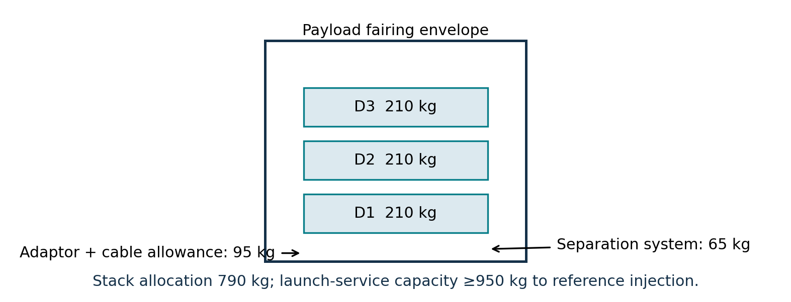
Figure 4 – Reference three-port launch stack. Dimensions and mass allocations are preliminary; the launch provider verifies fit, loads and separation clearances.
The launch campaign includes shipment, battery conditioning, propellant safety controls, combined electrical verification, dispenser integration and a separation-system test. Insurance, launch-service price, dispenser nonrecurring design and launch-site support are separately identified cost elements. A 30-day launch window is the planning assumption; monthly window sensitivity will be assessed in the schedule risk model.

5 Ground Segment and Mission Operations
Three geographically separated 12 m-class antenna sites provide scheduled X-band contacts and S-band contingency support. An assumed daily average of 60 minutes per spacecraft requires 3 antenna-hours/day before setup and maintenance; the 95th-percentile data case requires approximately 5 antenna-hours/day. A site outage shall be recoverable by rescheduling within 48 h under nominal geometry. Antenna geographic coordinates and visibility will be fixed at ground-network procurement.
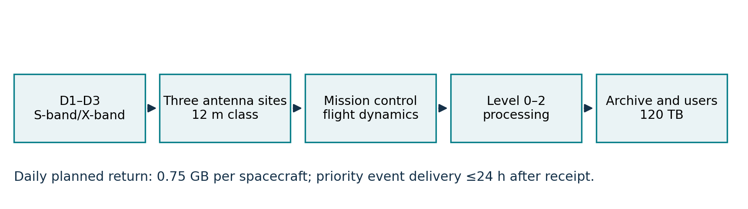
Figure 5 – Ground and data-processing chain. The three ground sites feed a common control and science system; labels state planning capacities.
Ground element | Planning scope
Mission planning and flight dynamics | Daily contact plan; weekly trajectory solution; thrust screening before each maneuver.
Spacecraft control | Three independently configurable flight units; one staffed shift per day and continuous automated monitoring.
Ground receiving | Three 12 m-class antenna sites; ≥15 GB/day raw ingest capacity.
Processing | Level 0 packets, calibrated Level 1 events/brightness, monthly Level 2 flux grids.
Archive and dissemination | 120 TB managed capacity with replicated metadata and controlled release; ≤24 h priority delivery after receipt.
The average combined downlink is 2.25 GB/day; five years produces approximately 4.1 TB raw science return before housekeeping and reprocessing. The 120 TB archive allocation covers replicated raw packets, calibration versions, intermediate products, sensitivity runs and metadata, a roughly 29-fold multiplier over raw science alone. This multiplier is an estimating allocation to validate through a data-management plan.

6 Systems Engineering and Project Management Approach

6.1 TRL Levels and Heritage
The common bus uses mature component classes, but its integrated three-unit deep-space configuration is a new qualification baseline. The impact front end and baffle are treated as critical development items. Critical payload elements shall demonstrate technology readiness level (TRL) 6 at preliminary design review and TRL 8 before flight acceptance; bus components target TRL 8 before spacecraft environmental qualification. Claims of heritage require part numbers, operating envelopes and qualification records, not resemblance of function.

6.2 Phasing Logic and Naming Conventions
Phase | Scope / nominal duration
PREP 1 / PREP 2 | Measurement simulations and detector prototypes; 6 / 6 months.
Phase 0 / A | Concept trades and mission definition; 8 / 10 months.
Phase B | Preliminary design, instrument breadboards and PDR; 14 months.
Phase C | Detailed design, critical tests and CDR; 12 months.
Phase D1 | Unit-level manufacture, assembly and environmental qualification; 18 months.
Phase D2 | System integration, acceptance, dispenser fit and launch campaign; 10 months.
LEOP | Separation and spacecraft commissioning; 1 month.
Phase E | Six-month cruise/commissioning total, then five-year nominal science phase.
Phase E EXT / F / G | Optional extension; passivation; continuing archive exploitation.
Dates in Table 4 are planning milestones, not contract commitments. Phase boundaries are set by accepted review products; the phase durations above overlap for long-lead procurement and unit builds and must not be summed to infer the launch date.

6.3 Project Milestones
Table 4 – Project Milestones
Phase | Gate / milestone | Major milestone | Date
0 | MCR | Mission Concept Review | Mar 2027
A | SRR | System Requirements Review | Jan 2028
B | PDR | Preliminary Design Review | Mar 2029
C | PL-CDR | Payload Critical Design Review | Feb 2030
C | CDR | System Critical Design Review | Mar 2030
D1 | MRR | Manufacturing Readiness Review | Jun 2030
D1 | DET-Q | Detector qualification complete | May 2031
D1 | FM-1 | First flight unit assembled | Oct 2031
D1 | FM-3 | Third flight unit assembled | Feb 2032
D2 | SIR | System Integration Review | Mar 2032
D2 | ETRR | Environmental Test Readiness Review | May 2032
D2 | AR | Flight-unit acceptance | Sep 2032
D2 | LRR | Launch Readiness Review | Nov 2032
D2 | L | Launch | Jan 2033
LEOP | SEP | All three units separated and acquired | Jan 2033
E | CCR | Commissioning Complete Review | Jul 2033
E | EOM | End nominal science operations | Jul 2038
F | EOL | Passivation complete | Sep 2038

6.4 Safety and Mission Assurance
The preliminary mission assurance posture requires traceable requirements, independent quality oversight of flight hardware, serialized configuration, formal nonconformance control, parts screening and supplier surveillance. Launch-site propellant handling and deployment hazards require approved procedures. The three-unit design is assessed for common-cause failure: one defective batch, flight-software defect or calibration error can affect all units, so unit-to-unit similarity alone does not establish independence.

6.5 Qualification and Acceptance Strategy, Model Philosophy
The model set comprises one electrical integration model, one structural/thermal qualification article for the common bus and three flight units. The detector front end receives a separate instrument qualification campaign with representative high-speed impact tests; the photometer baffle is qualified for stray light and thermal distortion. The qualification article undergoes vibration, shock, thermal-vacuum and electromagnetic compatibility tests. Each flight unit receives workmanship-level environmental acceptance, deployment tests, end-to-end contact demonstrations and calibrated payload acceptance.
Flight software is exercised against all three flight-unit configurations, including lost-contact, invalid time, low-power and wheel-failure cases. A 30-day post-launch checkout confirms each spacecraft independently; the remaining cruise interval establishes geometry and photometric reference fields. Acceptance evidence is archived by serial number and test configuration.

6.6 Risk Assessment
The Part C risk register controls probability, cost and schedule exposure. The highest concept-level drivers are detector calibration extrapolation to natural grains; photometer stray light at 40° elongation; ground-network coverage during unfavorable geometry; propulsion dispersion across the three drift trajectories; radiation-induced data corruption; and a common flight-software fault. Each risk requires an owner, quantitative trigger, mitigation and residual estimate. A technical reserve of 30 kg per unit and 34 m/s usable Δv headroom are design allocations, not substitutes for cost contingency.

6.7 Organizational Breakdown Structure
- Avelune Space Directorate: mission owner, systems authority, procurement, project controls and acceptance.
- Veylora Orbital Works: common spacecraft bus design, manufacturing and three flight-unit integrations.
- Kyntharel Instrument Works: impact detector, photometer, context package and payload calibration.
- Sorevian Launch Services: launch, dispenser integration and injection verification.
- Tavrel Ground Networks: three receiving sites and antenna scheduling.
- Ruvellan Data Institute: science calibration, inversion, product validation and archive stewardship.
A single interface-control register governs supplier boundaries. The prime spacecraft contractor integrates payload and bus and owns spacecraft-level verification; ASD owns mission-level acceptance. Subcontract pricing, long-lead orders and government labor allocations are defined in Part D and the associated cost breakdown structure.

Appendices

A Acronym List
Acronym | Definition
ADCS | Attitude Determination and Control System
ASD | Avelune Space Directorate
AU | Astronomical unit
CADRe | Cost Analysis Data Requirements
CDR | Critical Design Review
DSP | Dust Scattered-Light Photometer
EOL | End of Life
FM | Flight Model
IID | Impact Ionization Detector
LEOP | Launch and Early Operations
MDFO | Myralis Dust Field Observatory
PCS | Plasma and Context Sensor
PDR | Preliminary Design Review
RDI | Ruvellan Data Institute
SIR | System Integration Review
TRL | Technology Readiness Level
TT&C | Telemetry, Tracking and Command

